CS-004 Mold Sealing, Release & Surface Prep
Doc ID | CS-004
Title | Mold Sealing, Release & Surface Preparation (Polyurethane Tooling Board)
Revision | D
Status | Draft, pending Lead signature
Effective date | 2026-08-28
Supersedes | Duratec spray sealing (retired); SN5 Mold Sealer Alternatives study (2025-10-19, overtaken)

Approvals
Role | Name | Date
Author | Simon Starbuck (drafted with Claude, SN6 Resources) | 2026-07-12
Reviewer | simon (reviewer agent) — G2a | 2026-07-12
Approver (Composites Lead)

Revision history
Rev | Date | Author | Description of change
A | 2026-07-12 | Claude | Initial issue, codifies the XCR system adopted spring 2026; TDS numbers verified against R1
B | 2026-07-28 | Claude | Language pass: fewer em dashes for rhythm variety, no content change.
C | 2026-08-03 | Claude | New §7.5 Identify, the last step after every wet operation: where the mold label goes, the 40 mm flange keep-out, the 220-grit scuff, and the reprint-on-reseal rule (CS-001 §7.4).
D | 2026-08-28 | Claude | Engineering pass (CS-000 Rev C conventions). Figure 1 draws the full release stack in section and puts the overcoat window on a timeline, because the window is the one number in this doc that expires while you watch. No rule changed.

1. Purpose
Mold surface prep was our single most expensive recurring problem in SN5 (PP-01). Duratec was pricey, pooled in crevices and hid our scribe lines, needed high-grit sanding on soft board, and we sanded through it constantly; every incident cost a day-plus re-coat cycle. In spring 2026 we switched to XCR coating resin: paint it on, no sand-back, better finish, better geometric accuracy. This doc locks that decision in and gives one procedure from "machined mold" to "ready for layup", so the reasoning doesn't get lost and re-argued next year.

2. Scope
CNC-machined polyurethane tooling-board molds (30–60 lb/ft³, Coastal Enterprises stock) used for resin infusion or wet layup. Not covered: 3D-printed compression molds (CS-003 Appendix A) and hotwire foam male molds.

3. References
Ref | Document | Where
R1 | XCR Epoxy Coating Resin TDS | 04 Datasheets/EC-TDS-XCR-Epoxy-Coating-Resin.pdf
R2 | XCR SDS | 04 Datasheets/EC-SDS-XCR-Epoxy-Coating-Resin-Combined.pdf
R3 | Partall Film #10 (PVA) guide + SDS | 04 Datasheets/PARTALL-Film-10.pdf, SDS-PF10-5.5-en-NA-2025-01-28.pdf
R4 | Formula Five Mold Release Wax guide + SDS | 04 Datasheets/FORMULA-FIVE-Mold-Release-Wax.pdf, SDS-F5MRW-5.3-en-NA-2025-01-28.pdf
R5 | Formula Five Clean 'N Glaze guide + SDS | 04 Datasheets/FORMULA-FIVE-Clean-N-Glaze.pdf, SDS-CG-5.3-en-NA-2025-01-28.pdf
R6 | PP-01 RCA (Duratec history) | FEB-COMP-PP-001 §PP-01
R7 | SN4 Mold Manufacturing Problems and Solutions (cleanliness regimen) | SN5 Composites/Documentation/SN4 Mold Manufacturing Problems and Solutions.docx

Why these products: XCR is a purpose-made brushable epoxy coating (R1) that cures to a hard surface without requiring sand-back. It fixes exactly the two Duratec failure modes (mandatory sanding on soft board; pooling that hides marks). The Rexco release system (R3–R5) is sponsor-supplied (~free) and wax + PVA film is the industry-standard belt-and-suspenders release for epoxy on epoxy-sealed molds.
XCR key numbers (all from R1):
Property | Value
Mix ratio | 100 : 41 resin : hardener by weight (2 : 1 by volume; weight preferred)
Pot life (150 g mixed) | 8 min at 20 °C; 4 min at 30 °C
Overcoat window | apply next coat at firm-but-tacky: within ~2 h 50 at 20 °C / 1 h 30 at 30 °C
If tack-free / window missed | cure ≥9 h (20 °C), then key with 120-grit before recoating
Initial cure (handleable) | 8 h 30 at 20 °C; 4 h 30 at 30 °C
Full mechanical properties | ≥14 days at 20 °C (no post-cure oven available; plan mold use accordingly)
Application window | ambient 15–30 °C; ≥20 °C recommended and held through cure
Water exposure | none until ≥24 h after application

4. Definitions
- Sealing: closing the open cells of machined tooling board so laminating resin cannot soak in and lock the part on.
- Release system: the sacrificial layers (wax, then PVA film) that let the cured part separate from the sealed mold.
- Etch / scribe lines: machined reference marks on the mold (part trim lines, datums). Preserving their visibility is a hard requirement of sealing.
- B-stage / firm-but-tacky: resin firm enough not to flow, soft enough to indent with a fingernail, slight surface tack: the correct state for overcoating (R1).

5. Equipment & Materials
Item | Spec / product | Source | Notes
Coating resin | XCR (resin + hardener), 100:41 by weight | Easy Composites | R1. Order ≥6 weeks ahead (UK customs, PP-02)
Digital scale | 1 g resolution or better | RFS | Ratio errors = soft spots
Mixing cups ×2 per batch | Graduated | Consumables box | Double-pot per R1 (transfer + remix)
Brushes | Disposable, solvent-safe | Consumables box | One per batch; do not clean/reuse
Compressed air | Shop air / duster | RFS | Step 7.1
Isopropyl alcohol + microfiber cloths | ≥90% IPA | Chemicals box | Never acetone, never fibrous shop towels (R7)
Release wax | Formula Five Mold Release Wax | Rexco (sponsor) | R4
PVA release film | Partall Film #10 | Rexco (sponsor) | R3
Mold cleaner | Formula Five Clean 'N Glaze | Rexco (sponsor) | R5, for re-used molds

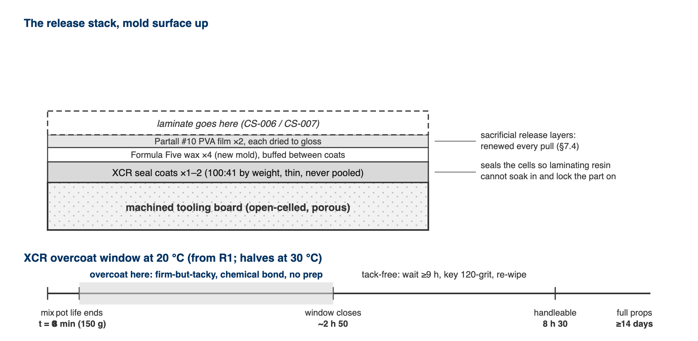
Figure 1. Top: everything that ends up on the mold surface, in order. Bottom: the XCR overcoat clock at 20 °C; the shaded span is the firm-but-tacky window where a second coat bonds with no prep.

6. Safety
Per R2 (XCR SDS): the mixed system is a skin and respiratory sensitizer. Repeated careless exposure can make you permanently allergic to epoxies, which ends your composites career.
- Gloves: nitrile (chemical-resistant per EN ISO 374-1), always, both components and mixed resin. Change gloves if resin gets on them.
- Ventilation: use only with adequate ventilation (R2 §8.2). Seal molds in the open shop area or with doors open, not in a closed side room.
- Respirator: for prolonged brushing on large molds (undertray-scale) or poorly ventilated conditions, wear the team respirator with A-type (brown, EN 14387 A1) organic-vapor cartridges; dust filters alone do nothing against epoxy vapors.
- Eyes/skin: safety glasses when mixing/pouring; wash any skin contact immediately with soap and water (not solvent). Contaminated clothing stays at the shop (R2 P272).
- Exotherm: mixed XCR left in the pot self-accelerates (R1). Small batches, transfer to the surface promptly; if a cup gets hot/smokes, set it outside on concrete and let it finish; do not bin it hot (see CS-008).
- PVA/wax (R3–R5): low hazard; gloves and ventilation suffice.

7. Procedure

7.1 Clean after machining
- Blow all dust off the mold with compressed air, including pockets and scribe lines.
- Wipe the entire surface with IPA-dampened microfiber cloth; repeat with a clean face until the cloth comes away clean.
⚠ CAUTION: Never use acetone on tooling board (it attacks the board) and never use fibrous cloths/paper shop towels (strings pull out and embed in the surface): both are SN4-documented failure modes (R7).
- From this point, gloves only; skin oils contaminate the surface.

7.2 Inspect and touch up
- Check every scribe line and datum is crisp and visible. Photograph the dry mold; this is the reference for "did sealing obscure anything".
- Fill any machining defects/gouges per CS-003 before sealing.
[ PHOTO: machined, cleaned mold with scribe lines visible, before sealing ]

7.3 Seal with XCR
- Confirm workspace is 15–30 °C and can stay ≥20 °C through the cure (R1). Do not seal outdoors on cold evenings; the cure stalls below 15 °C.
- Batch size: mix ≤150 g at a time. Pot life at that size is only 8 minutes at 20 °C (4 at 30 °C), and a bigger batch is shorter-lived and hotter. A 150 g batch covers roughly a medium mold section per coat; mix again rather than mixing big. Record each batch mass on the WO.
- Weigh XCR at 100:41 resin:hardener by weight (R1). Mix thoroughly ≥2 min, scraping walls and base; then double-pot: transfer to a second cup and remix with a fresh stick (R1). Unmixed streaks from cup walls are the classic soft-spot cause.
- Brush a thin, even first coat over the whole working surface plus flanges, working quickly (see step 2's clock). Work resin out of corners and fillets: pooling in crevices is the Duratec failure mode we are not repeating; a thin coat that needs a second pass beats a thick coat that pools.
- Watch scribe lines as you coat: they must remain visible. If a line floods, drag the brush along it to re-open the meniscus before the resin gels.
- Second coat timing: overcoat when the first coat is firm-but-tacky, within ~2 h 50 at 20 °C (1 h 30 at 30 °C), and it chemically bonds with no prep (R1). 30 lb board usually needs a second coat; 60 lb board often seals in one. If the window is missed (tack-free), wait ≥9 h from application, key with 120-grit, blow + IPA-wipe, then recoat.
- Initial cure is 8 h 30 at 20 °C (R1); the mold is handleable after ~9 h. Only if a run/nib formed: locally denib with ≥800 grit, then re-wipe with IPA.
- Keep water away from the sealed surface for 24 h (R1).
⚠ CAUTION: Mix only a ≤150 g batch and get it out of the cup fast. At 8 minutes of pot life, a phone call is the difference between a coat and a smoking cup.
[ PHOTO: first XCR coat going on, brush working resin out of a fillet ]

7.4 Apply release system
- On a fresh sealed mold: apply Formula Five wax per R4: thin film, let haze, buff with clean microfiber. 4 coats minimum on a new mold, buffing between coats.
- Apply Partall #10 PVA film per R3: thin, even coats; let each dry fully (it dries to a visible glossy film). 2 coats.
- On a re-used sealed mold: clean with Clean 'N Glaze (R5), then 1–2 wax coats + PVA as above.
- Mark the mold's record with sealing and release done (who, when, products, batch masses, coat counts), and set its stage to Sealed.
[ PHOTO: PVA film drying: even gloss, no fisheyes ]

7.5 Identify
The last step, after every wet operation is finished. Doing it earlier does not work: a label applied before the XCR either gets brushed over, becoming a permanent bump in the seal coat, or gets peeled off and leaves adhesive the XCR will not wet out.
- Choose a patch on the back face, at least 25 mm inboard of the mold outline on every side. Never the working surface. Never within 40 mm of the flange perimeter: tacky tape is 12.7 mm wide, and a label edge under the seal is a leak channel you will not find at 27 inHg (CS-001 §6).
- Scuff the patch to 220 grit and wipe with IPA. Tooling board is porous; without this the adhesive has nothing to key into and the label curls off within a month.
- Print the mold's label from the app and apply it. Check the printed parts-pulled count and seal date match what you just recorded.
- Confirm the engraved ID from CS-005 is still legible. If machining or rework removed it, re-engrave or stamp before the mold leaves.
⚠ CAUTION: On a re-seal, the old label comes off with the strip and a new one is printed carrying the new seal date and the incremented parts-pulled count. A label reading SEALED 2025-11-02 · USES 09 is telling you something important, and reprinting is how it stays true.

8. Quality checks / acceptance criteria
Check | Target | Method | Record where
Scribe/datum visibility after sealing | All lines identifiable vs 7.2 photo | Visual compare | WO qualityChecks + photo
No pooling | No glossy pools in fillets/corners | Visual, raking light | WO qualityChecks
Cure | Fingernail does not mark surface at 24 h | Press test on flange (not part surface) | WO step
Release film | Continuous PVA gloss, no fisheyes/dry patches | Visual | WO qualityChecks
First-article release (new mold or new product batch) | Test patch releases by hand | Small cured resin dab on flange, pop off | WO notes

9. Records
The mold's work order records: sealing date/operator, XCR batch masses + count, coat count and timing (in/out of overcoat window), wax/PVA coat counts, the 7.2 and 7.4 photos, and the quality-check table. This is what makes "why did part X stick?" answerable in minutes.

Appendix: the Duratec history (why XCR)
Duratec (SN4–early SN5): expensive, hid etch marks by pooling, mandatory high-grit sand-back on soft board, frequent sand-through → re-coat cycles. The Oct 2025 Mold Sealer Alternatives study recommended S120/water-based sealers as a cheap replacement; by Feb 2026 the team instead ordered XCR with the Easy Composites basket, first parts sealed with it in April 2026 ("Core and XCR has arrived, good to seal", #composites, 2026-04-28), and the undertray was coated with XCR in May. Root-cause note (PP-01): the durable fix wasn't the product swap itself but owning the selection decision in a standard, this document. If XCR is ever replaced, revise this standard (CS-000 §7.2), don't just switch cans.

